Power BI Dashboard Creation and Data Visualization
WAREHOUSE CREATION:
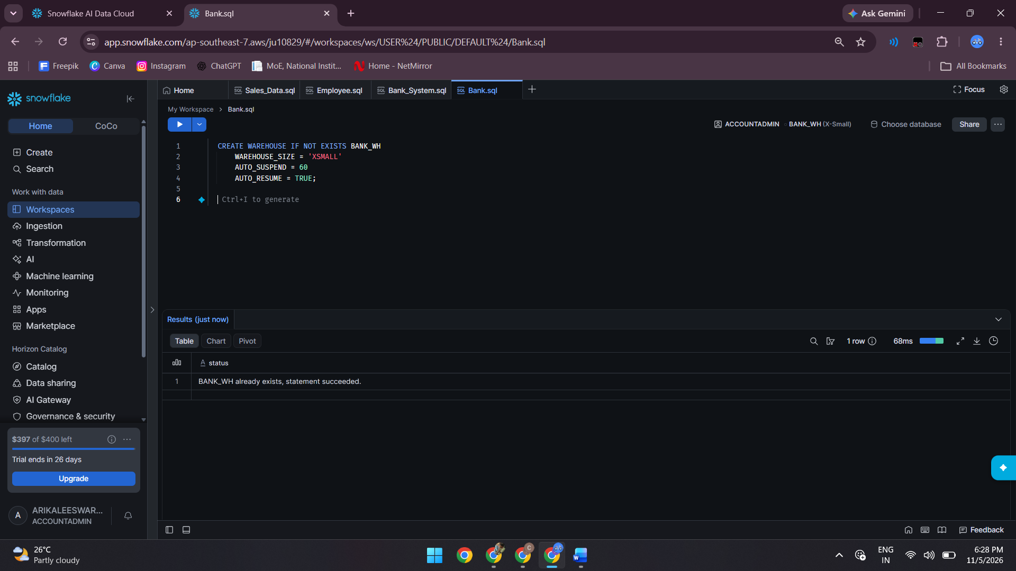
TABLE CREATION:
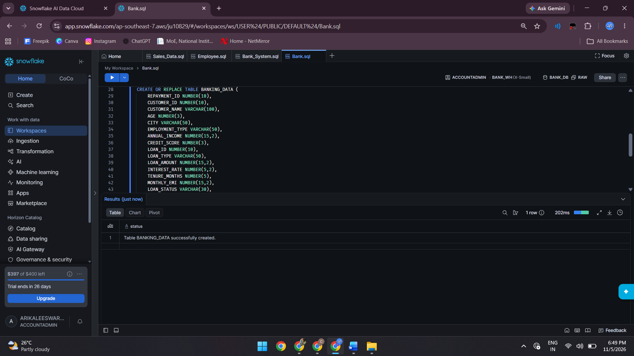

FILE FORMAT AND STAGE:
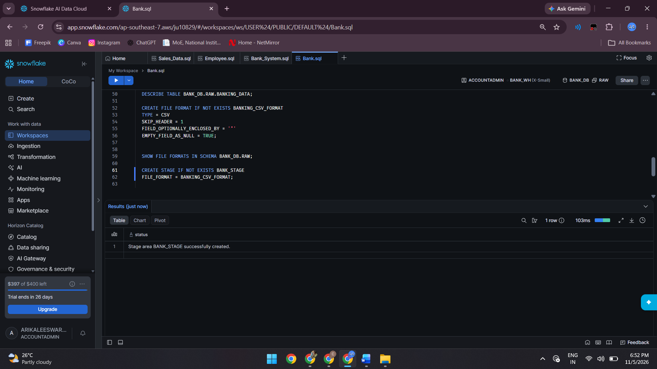
UPLOAD DATA:
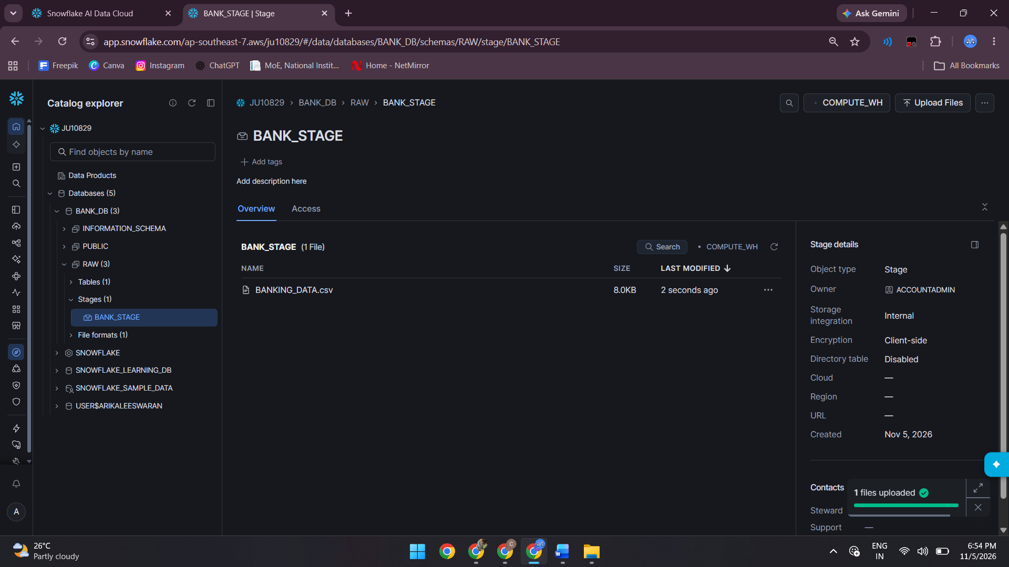
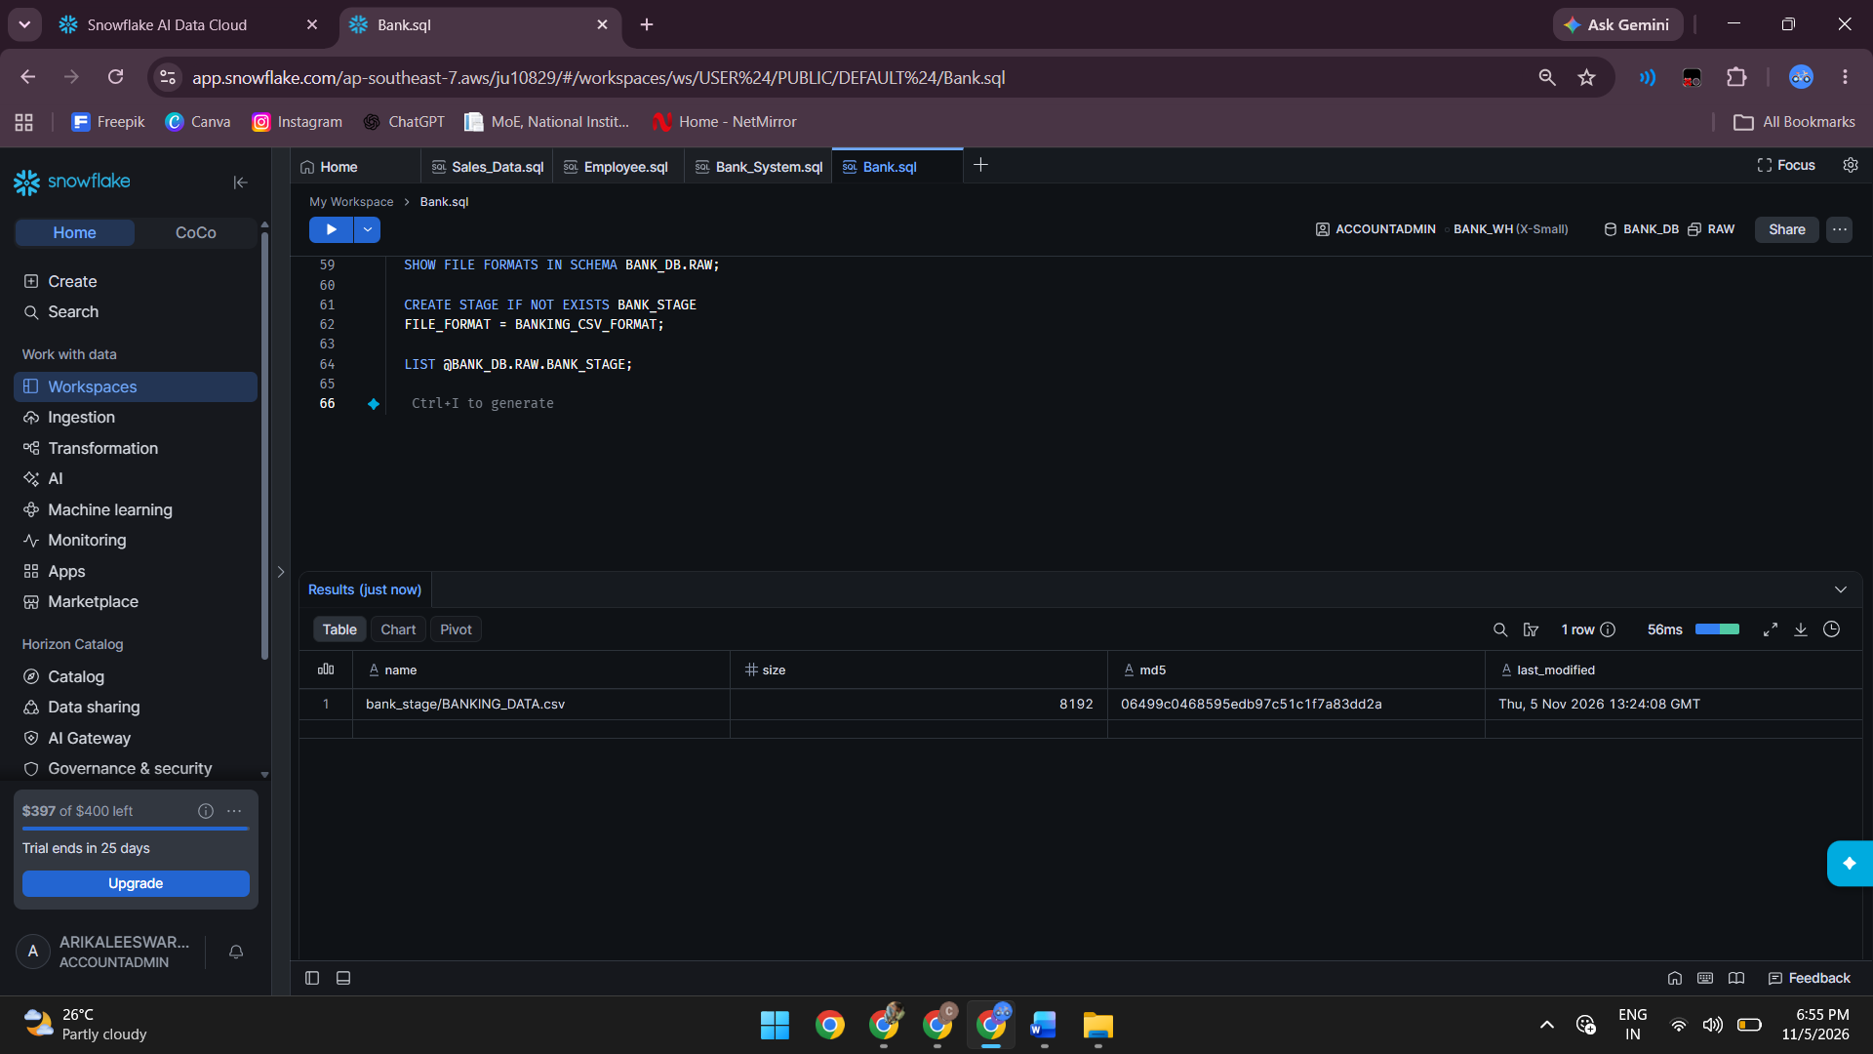
COPY INTO:
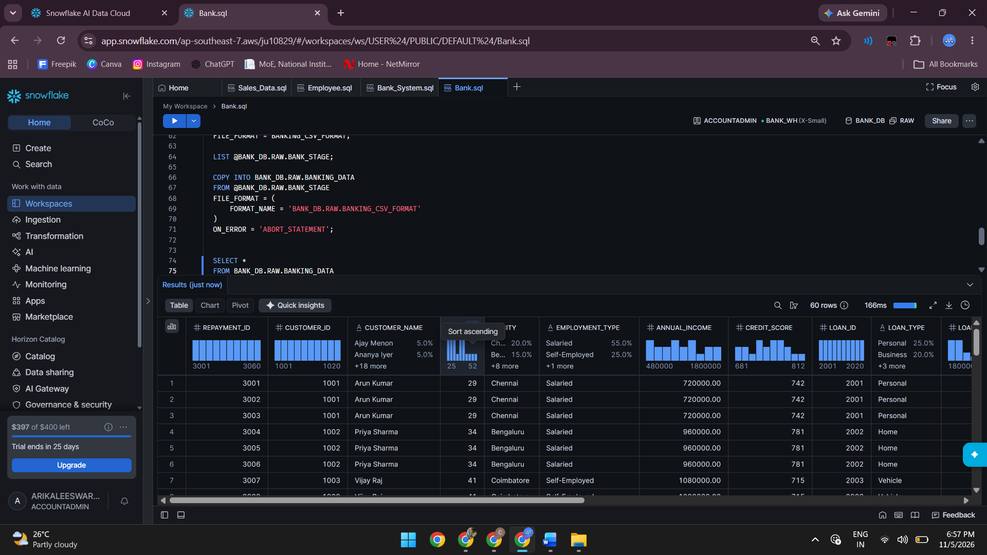

CHECK THE DATA:
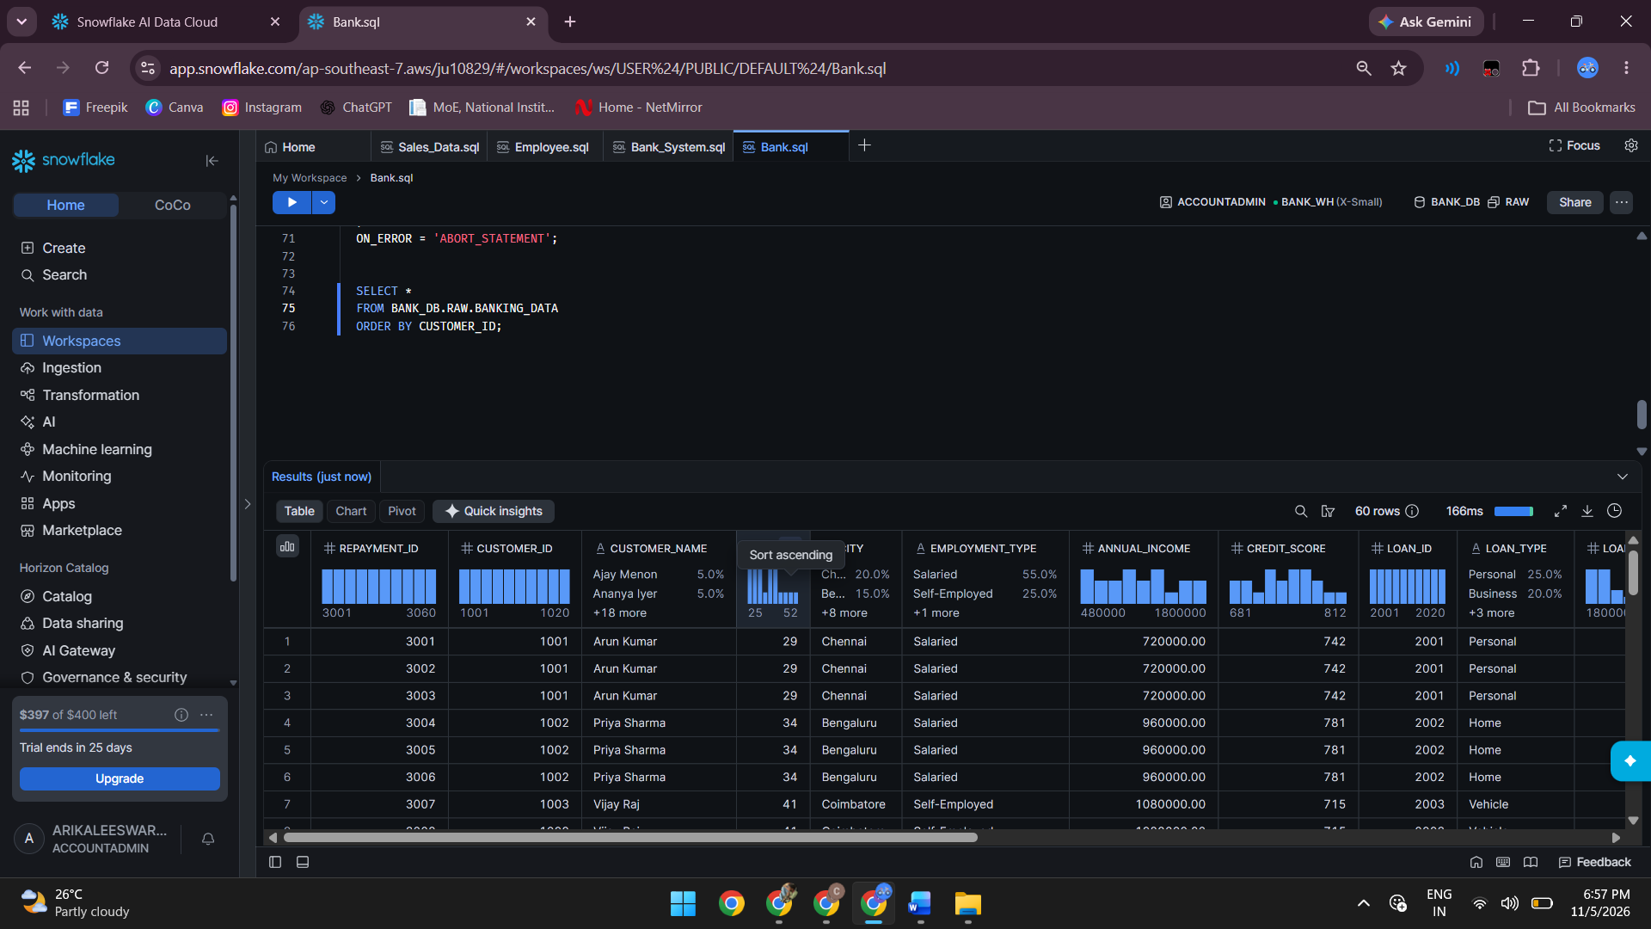
Connecting Snowflake with Power BI:
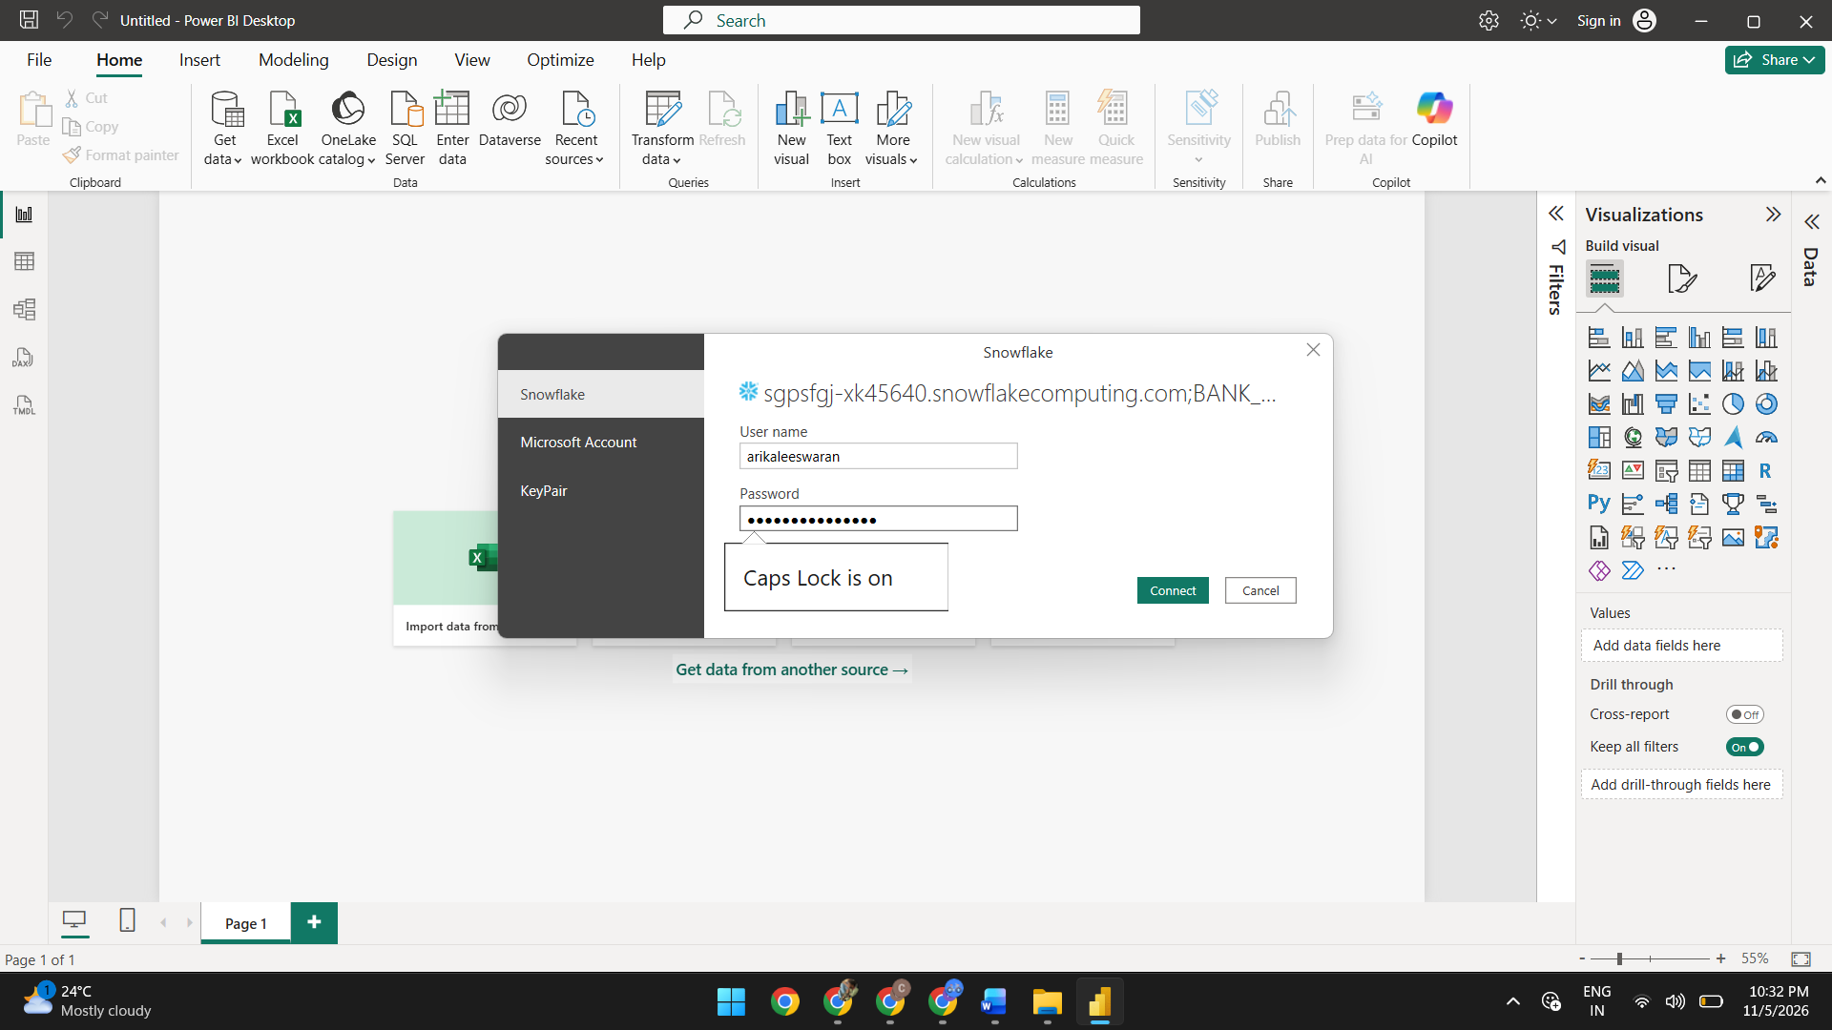
CHOOSE DB AND TABLE:
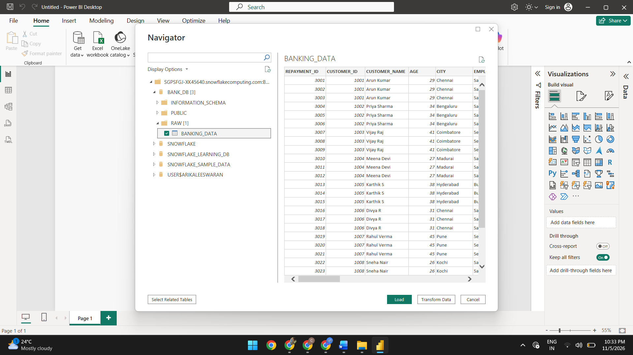
TRANSFORM DATA:
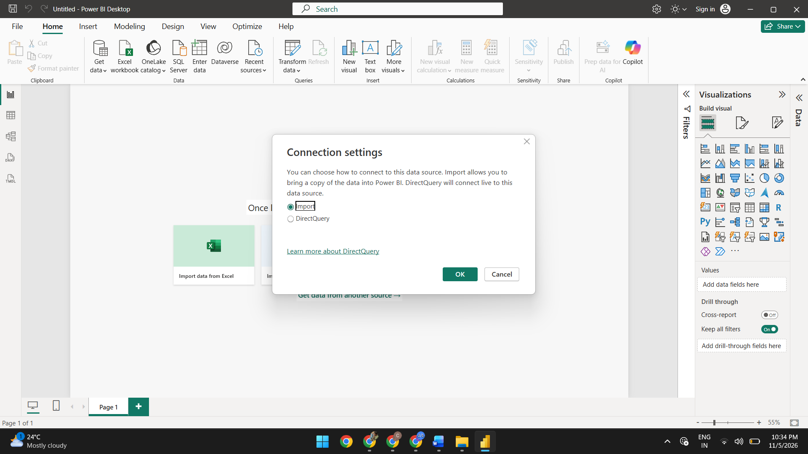

OPENING IN POWER QUERY:
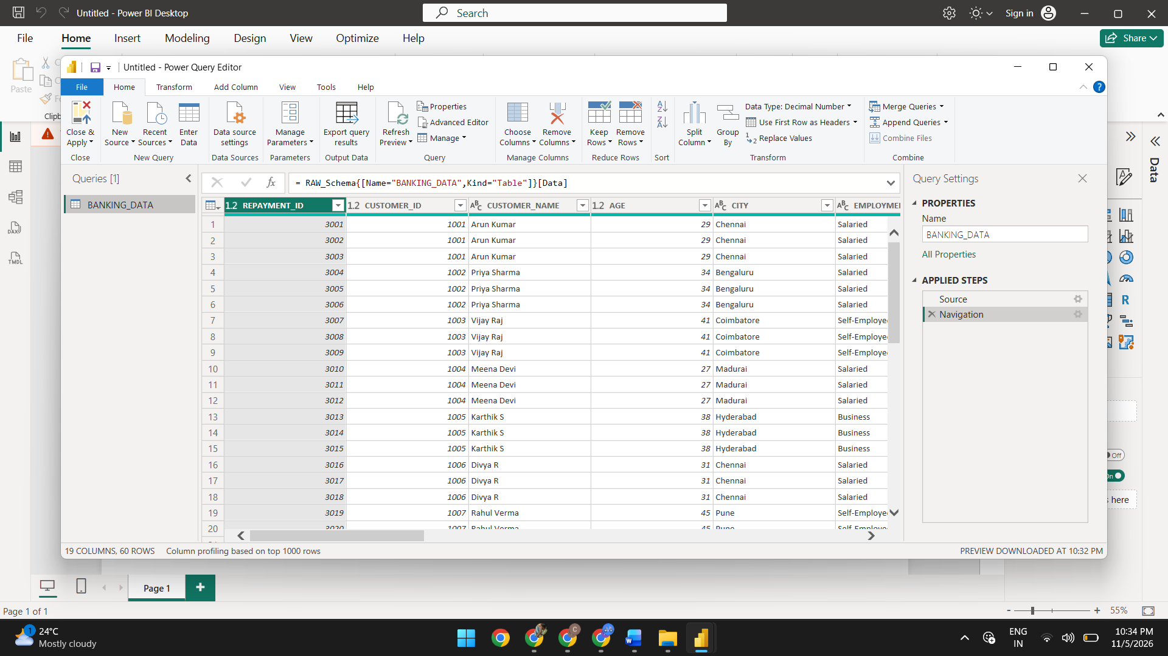
TRIM WHITESPACES:
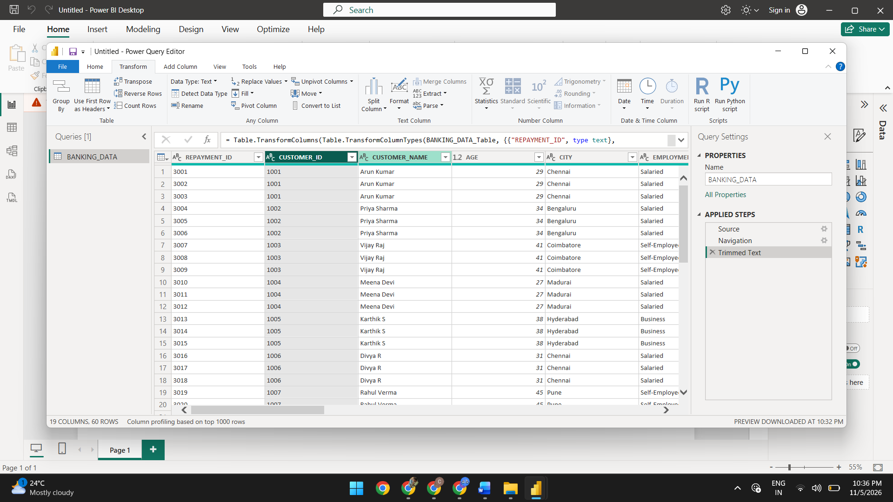
ADDING NEW COLUMN:
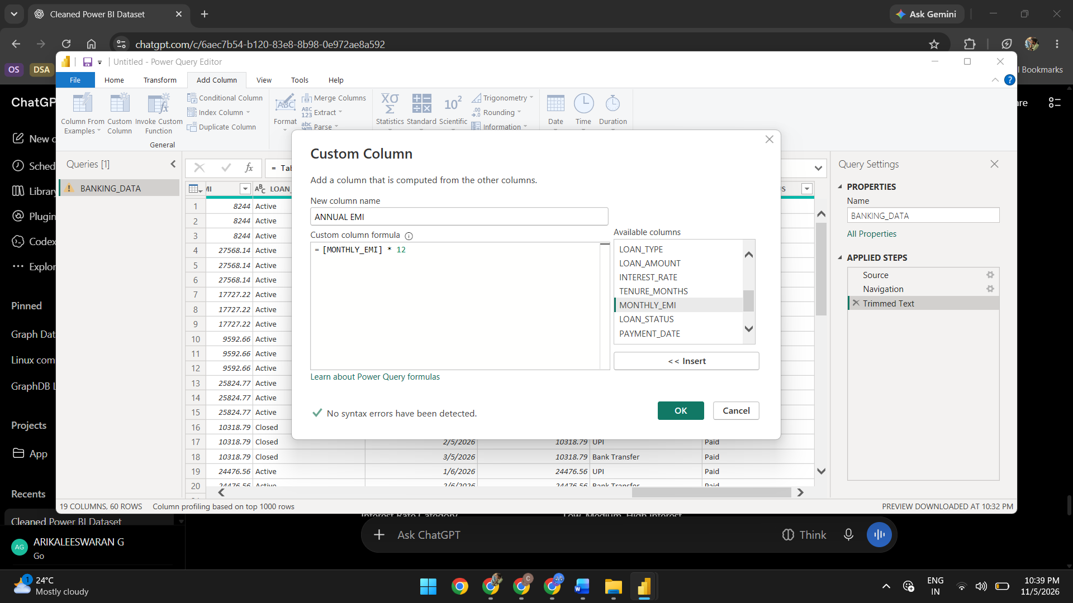
CHANGE DATA TYPE: (DATA TRANFORMATION)
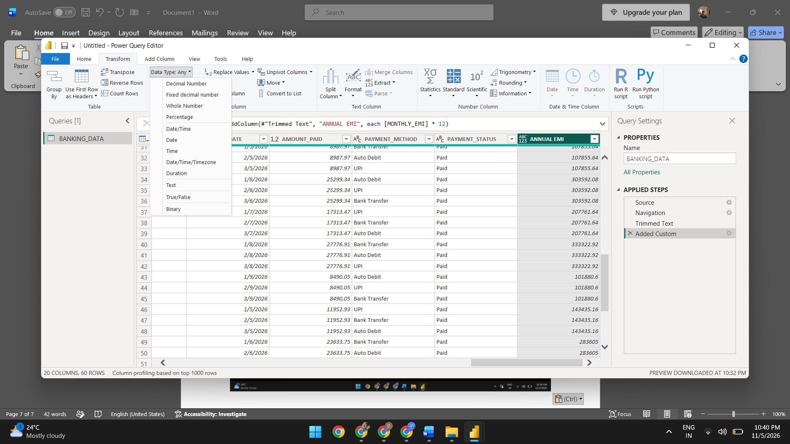
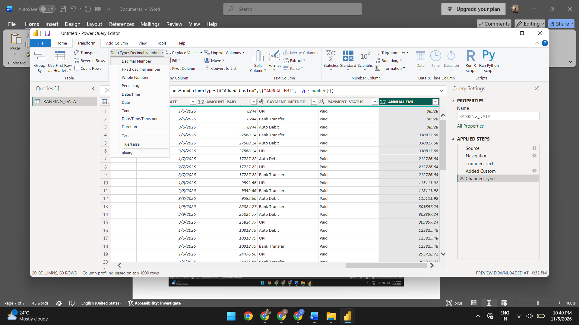
CLOSE AND APPLY:
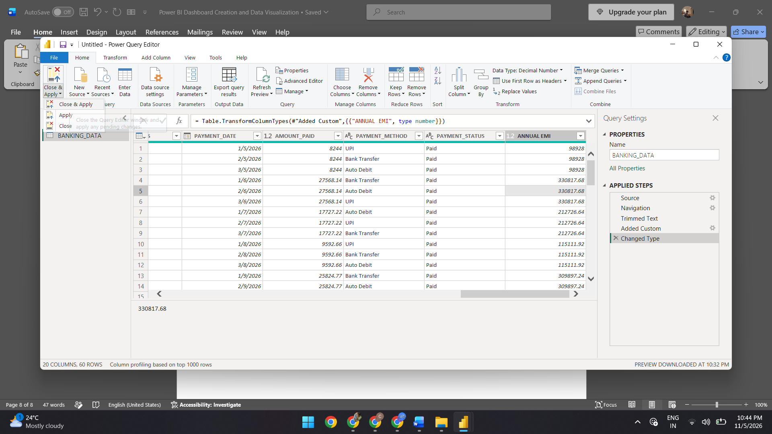

LOADING DATA:
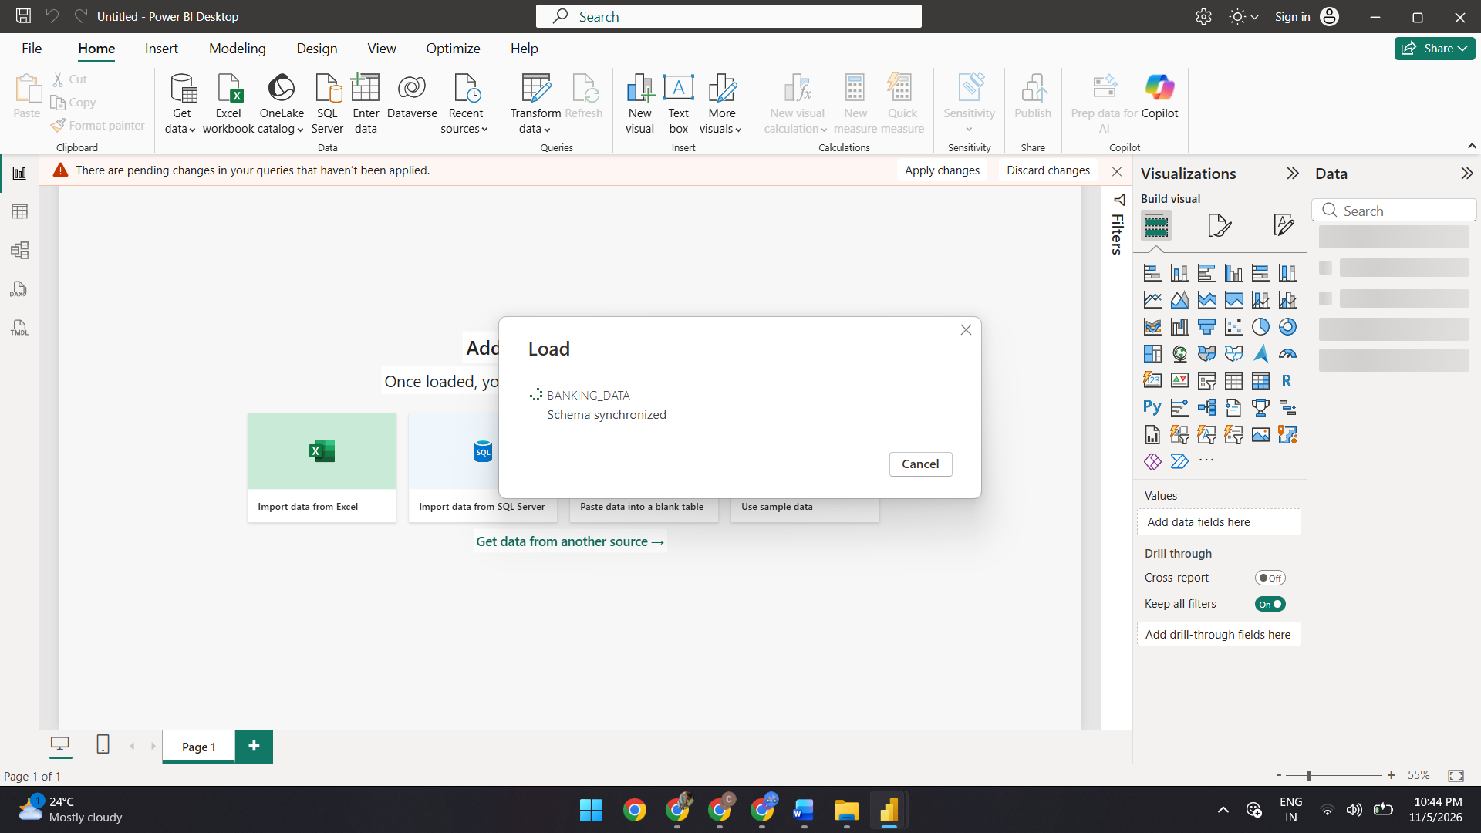
ADDING NEW MEASURES:
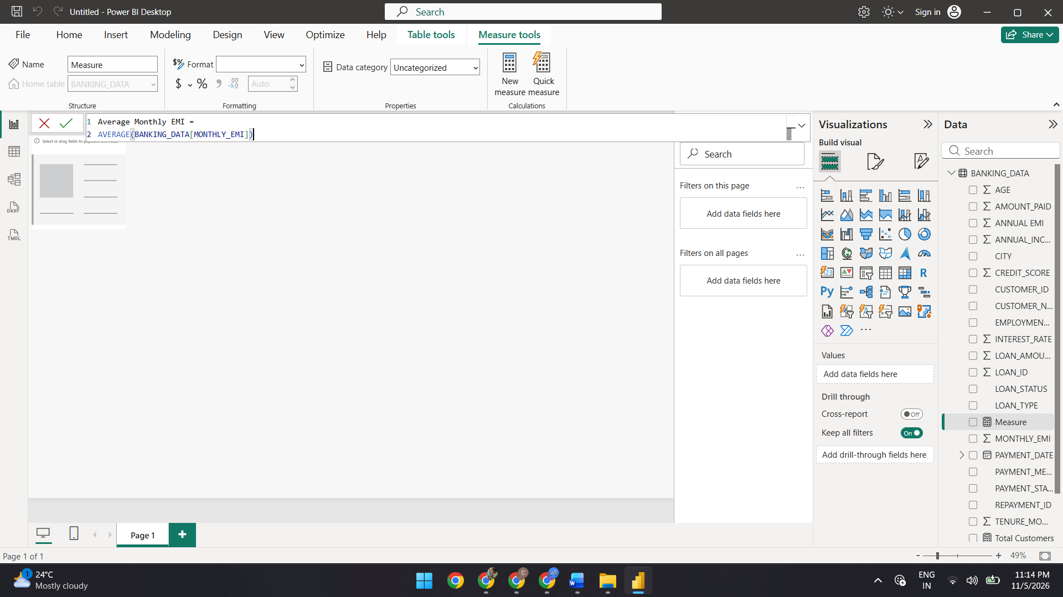

ADDING KPI CARDS:
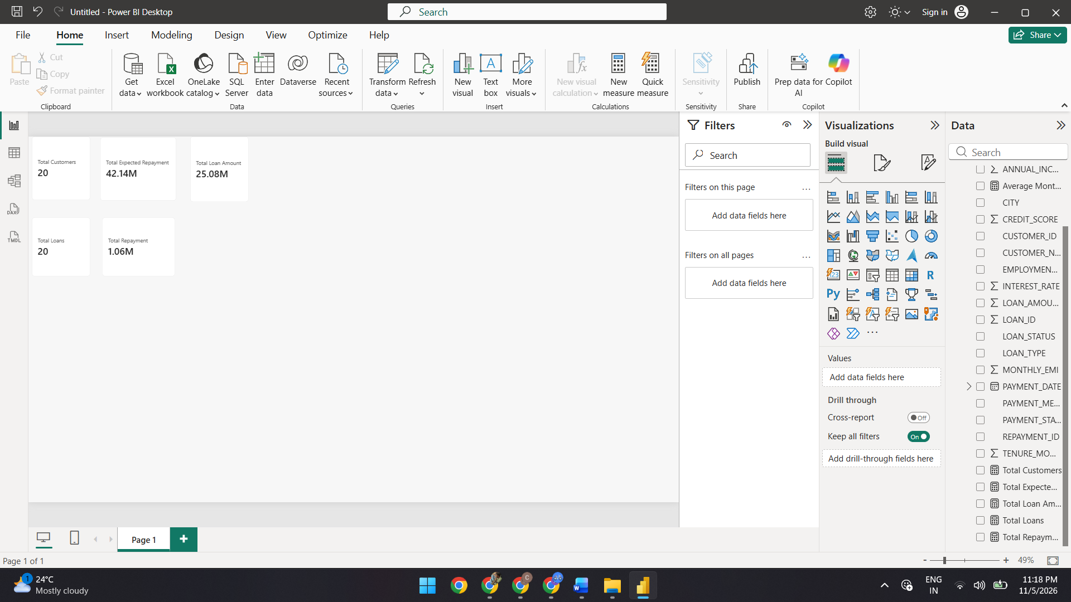
ADDING DONUT AND BAR CHART:
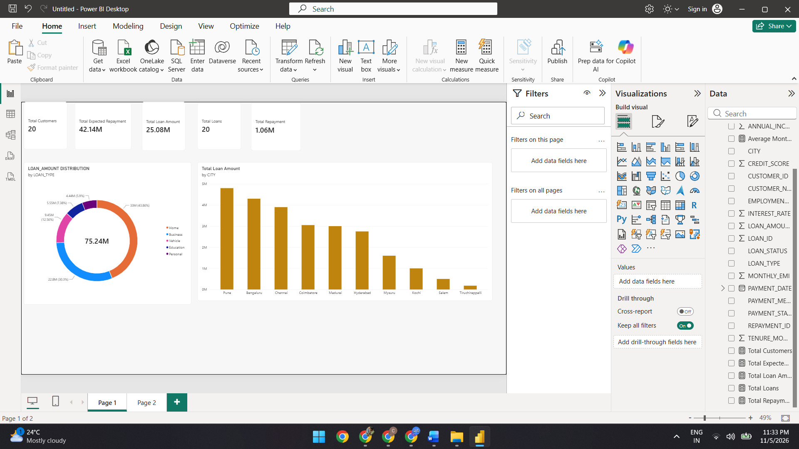

ADDING CLUSTERD BAR CHART AND PIE CHART:
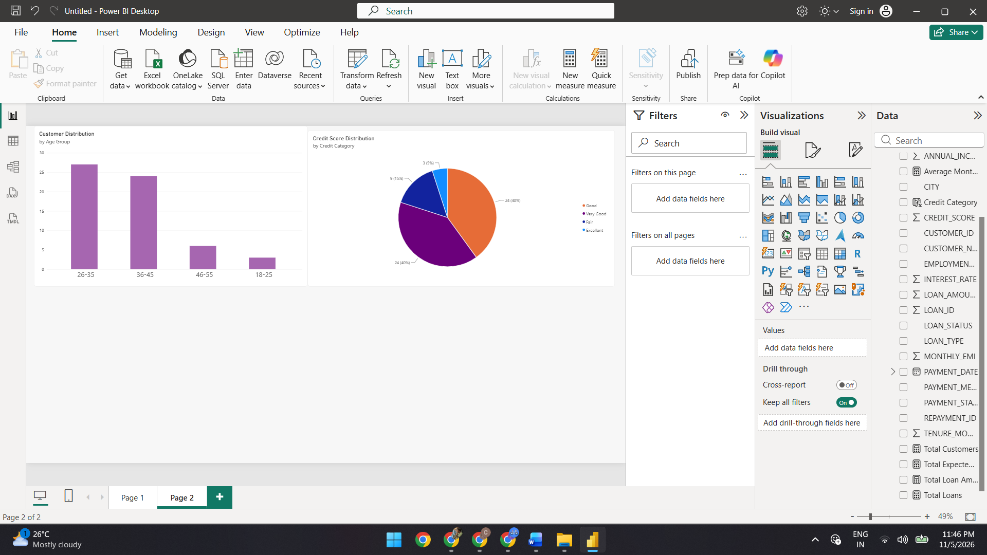
ADDING SLICER:
CITY SLICER:
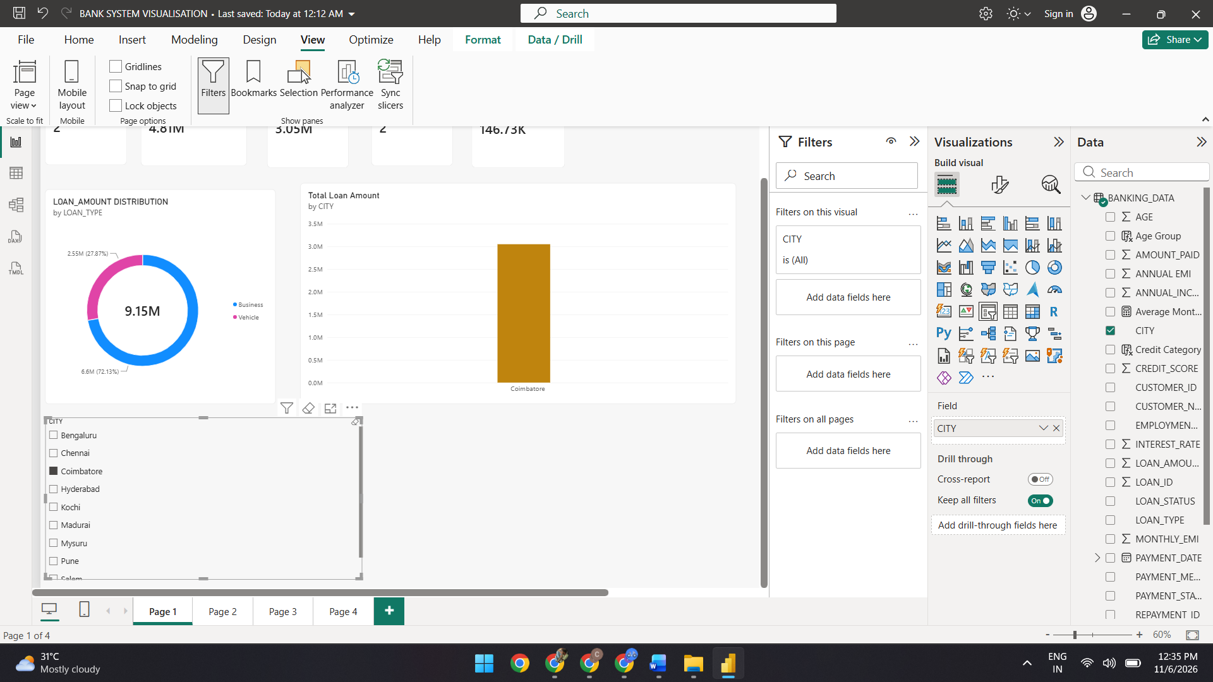

LOAN TYPE SLICER:
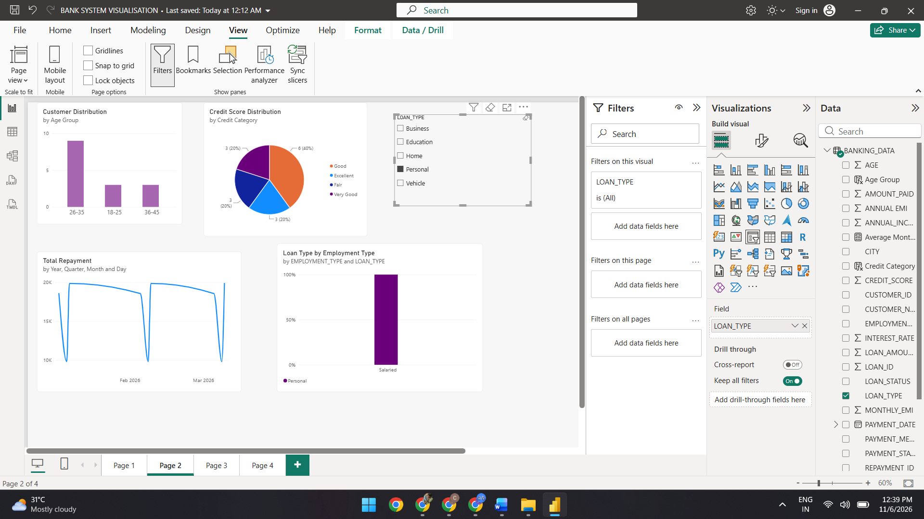
SLICER WITH EMPLOYEE TYPE:
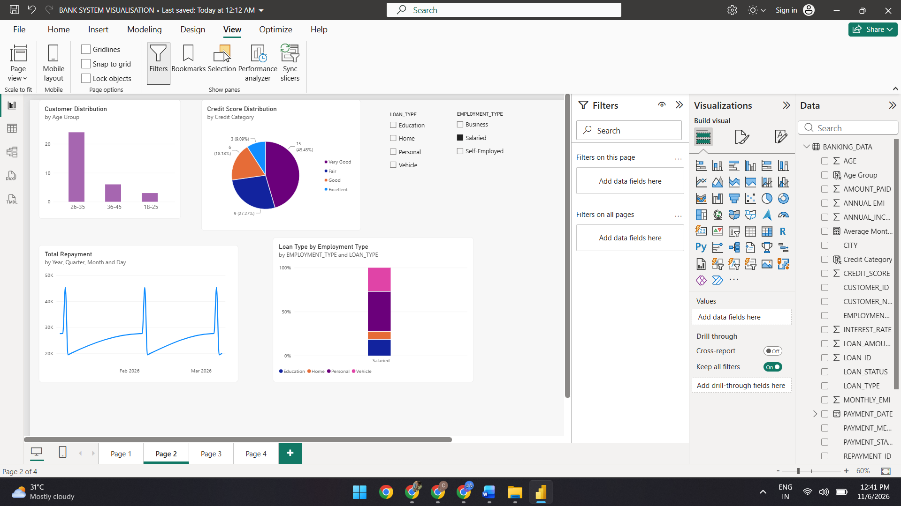

SLICER FOR AGE GROUP:
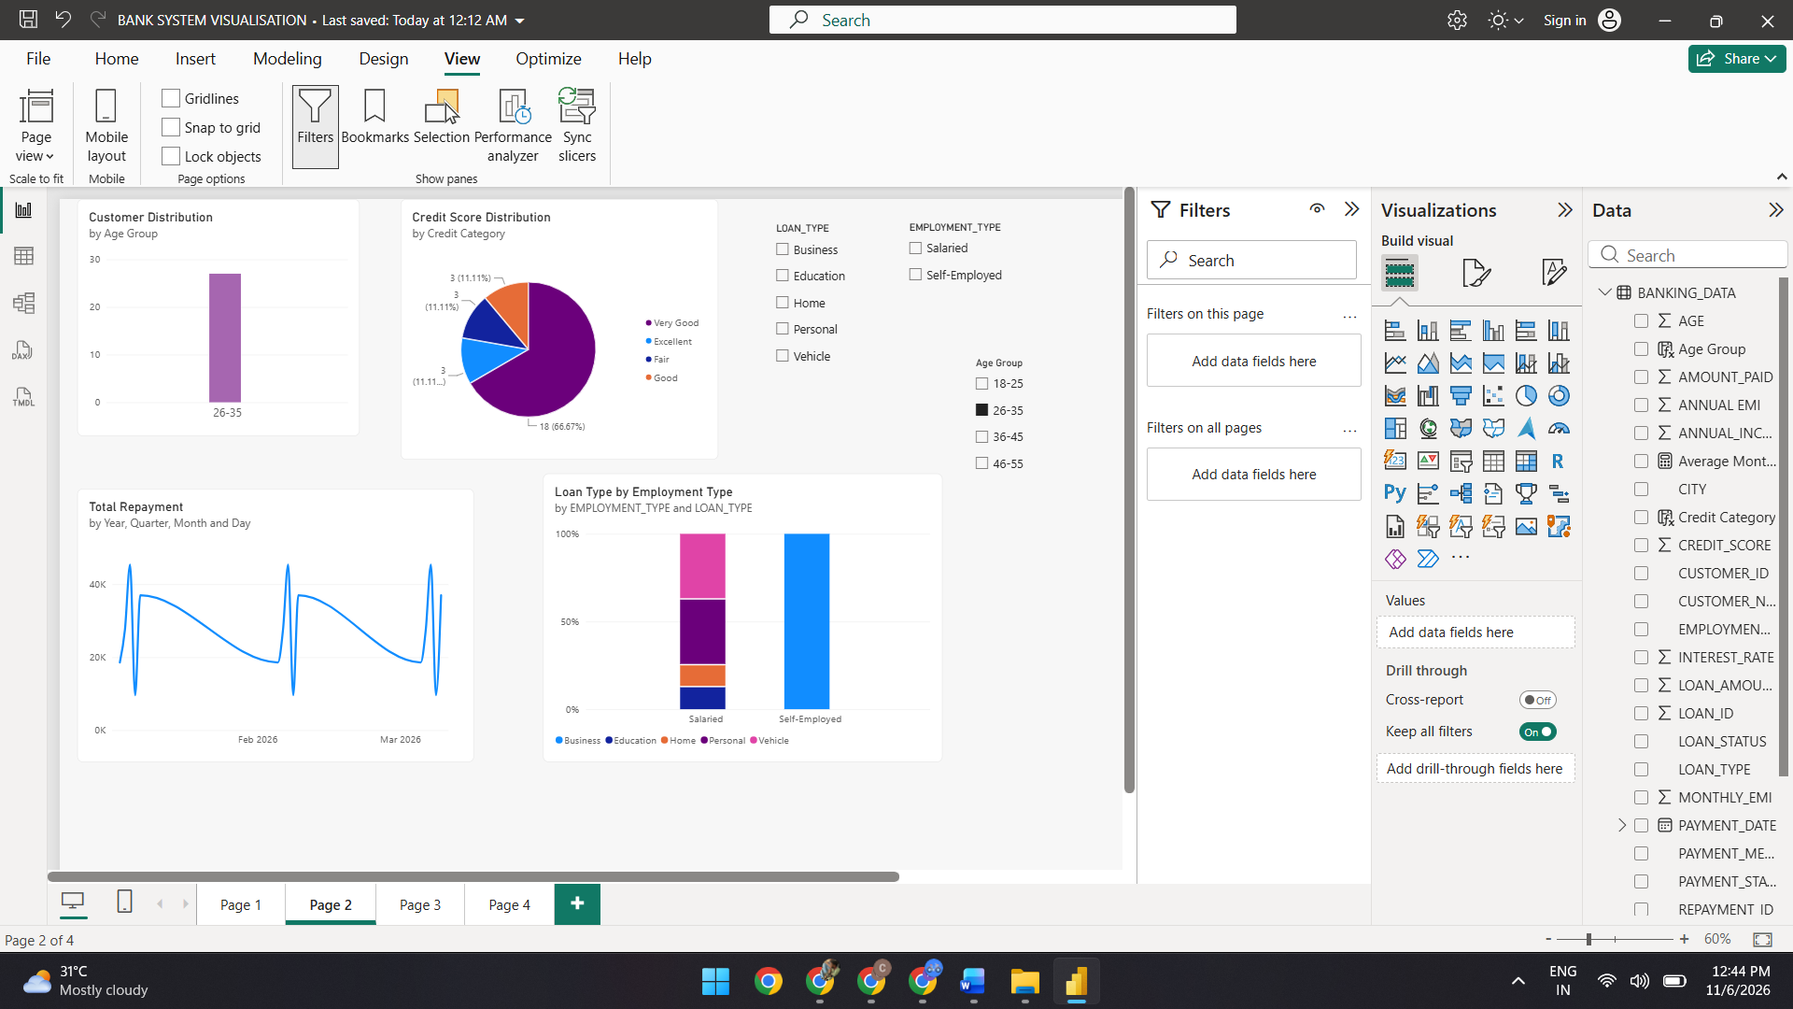
SLICER FOR CREDIT CATEGORY:
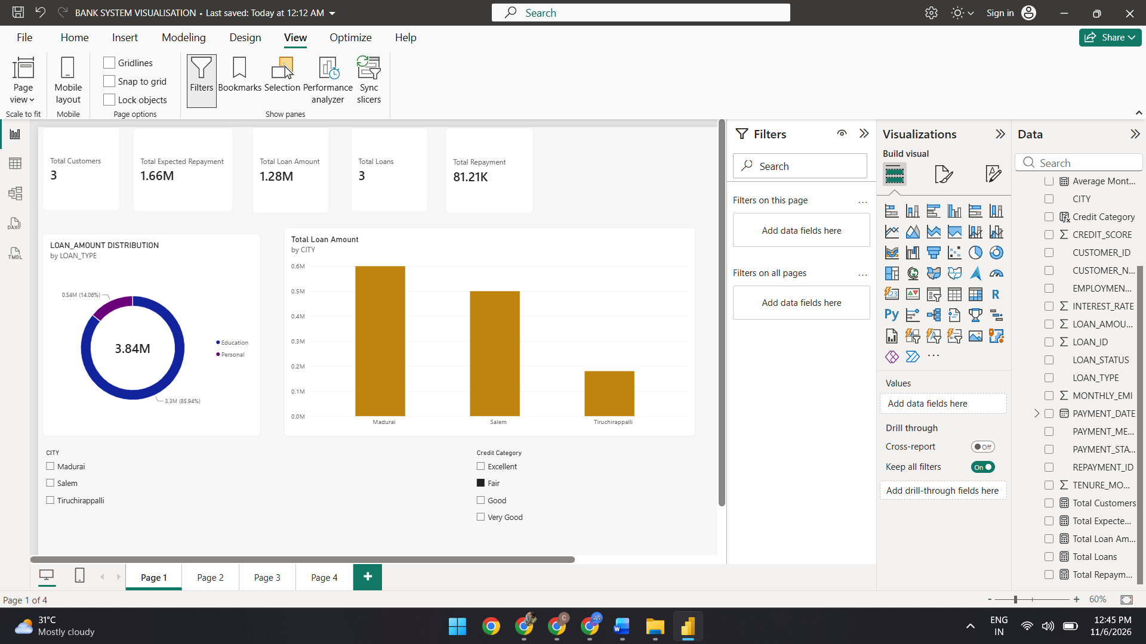

SLICER FOR PAYMENT YEAR:


